High resolution digital images available upon request

Please contact Maja Orsic, maja@robertkleingallery.com

June 25, 2014

FOR IMMEDIATE RELEASE – BOSTON

This Summer, Karen Halverson at Robert Klein Gallery and Gohar Dashti at Ars Libri

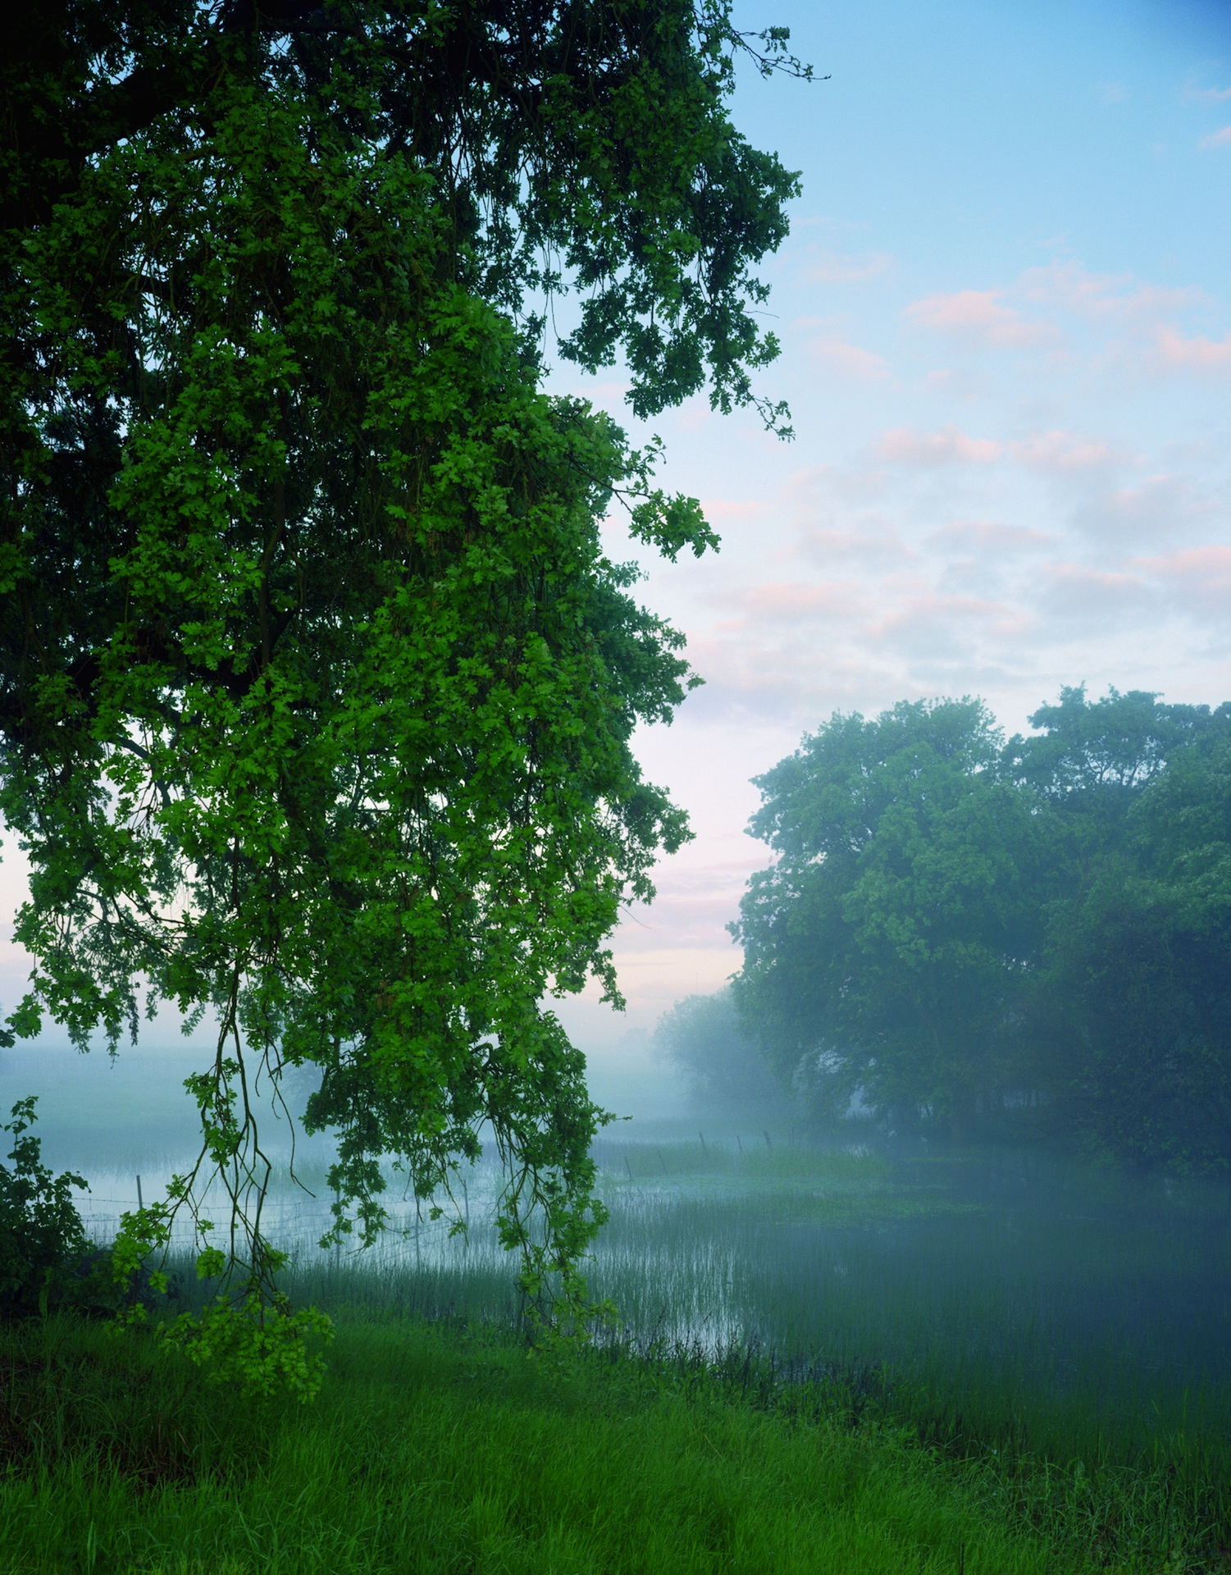 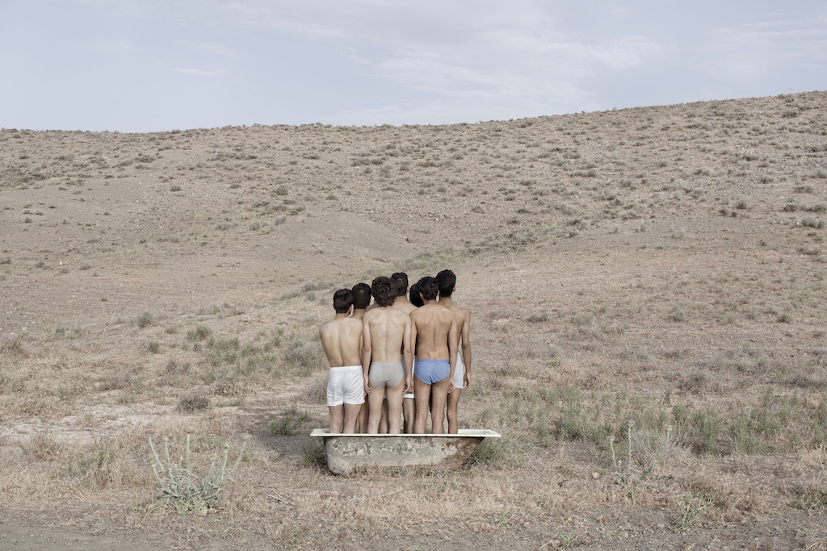

***Survey Iran, Untitled***

Photographs by Karen Halverson Photographs by Gohar Dashti

Robert Klein Gallery Robert Klein Gallery @ Ars Libri

38 Newbury St 500 Harrison Ave

July 10 – August 29, 2014 July 11 – August 29, 2014

BOSTON, MA – This summer, Robert Klein Gallery explores landscapes and human nature with two distinct exhibitions of photographs. *Survey*, which features photographs of Iceland and the American West by Karen Halverson, opens July 10, 2014, at Robert Klein Gallery (38 Newbury St). *Iran, Untitled*, a 2013 series by Gohar Dashti, will be shown in its entirety at Robert Klein Gallery @ Ars Libri (500 Harrison Ave) beginning with a First Friday reception on Friday, July 11, 2014 from 5:30 to 7:30 PM.

*Survey* is Karen Halverson’s first solo show at Robert Klein Gallery. Although she is not overtly polemical, Halverson does aim to show the multiple facets of any situation through her work, which explores “how we encounter, occupy, and alter the land.” She looks for manmade traces, large and small, on the landscape. What she finds may be indistinct – a wire fence in the background, made ghostly by the fog, as in *Valley Oak, Cosumnes River Preserve, California*, 2000 – or blatant, as with a weathered orange shed and gravel road in *North of Hveravellir, Iceland*, 2012.

There is an ebb and flow to these images, often as subtle as clouds moving across the sky, that affords the viewer “pasture enough for [the] imagination,” to quote Henry David Thoreau. These are not decidedly environmentalist pictures nor are they intended purely for decoration. They are not landscapes in the traditional sense of the genre. Instead, employing scale and humor for effect, these photographs document mankind’s eternal struggle with nature: the battles it wins and the battles it loses.

– MORE –

When dams and power stations enter her viewfinder, Halverson cedes the frame and we are left to consider the power of industry over the natural world. But Halverson often finds man’s own triviality in the presence of natural landmarks; in her 1995 image of *Davis Gulch, Utah*, plastic white lawn chairs are dwarfed by a soaring wall of red rock.

For Gohar Dashti, an Iranian photographer exploring the mindset of her countrymen, natural landscapes reflect internal geographies. Her complete 2013 series, *Iran, Untitled*, will be exhibited at Robert Klein Gallery @ Ars Libri, her second solo show in the space this year as part of a series of exhibitions of contemporary Iranian artists.

With a dusty palette of blues, greens, and browns, Dashti uses Iran’s desert as a backdrop for her narratives. Weddings, funerals, waiting in line: the barren landscape where Dashti sets her scene plays home to some of our regular shared experiences. But there is something curious to the subjects contained within the frame. In the wedding scene, there is not one bride and groom but many, and their dancing is confined to the limits of one large Persian rug laid out on the bare ground. In another image, seven young men stand in a ceramic bathtub in their underwear, their faces turned away from the camera. As before, their combined footprint is restricted to a defined space.

Dashti’s use of repetition to communicate themes is particularly effective in this series. In her 2008 work, *Today’s Life and War*, she situated her subjects in various battlefield strewn with debris. With *Iran, Untitled*, she is more concerned with containment, a phenomenon many outspoken Iranians experienced after the 2009 election of Mahmoud Ahmadinejad. These images are outspoken, but not

Both shows run through August 29, 2014.

ROBERT KLEIN GALLERY was established in 1980 and ranks among the world's most prestigious showrooms of fine art photography.

Robert Klein opened his Newbury Street space with early exhibitions of Diane Arbus, Annie Leibovitz, Sally Mann, and Hiroshi Sugimoto. From 1995 through 2008, Robert served as President of the Board of Directors of the Association of International Photography Art Dealers (AIPAD). During his tenure, Robert engineered the 2006 expansion of The AIPAD Photography Show New York to the Park Avenue Armory. The AIPAD Photography Show's move firmly established it as one of the leading photographic fairs in the world.

Robert Klein Gallery maintains an extensive and ever-changing inventory of 19th century, 20th century, and contemporary photographs. Participating in international art fairs such as Paris Photo, The Armory Show – Modern, and The AIPAD Photography Show in New York, Robert Klein Gallery provides its contemporary artists with international exposure while exhibiting works by recognized masters such as Ansel Adams, Helen Levitt, and Irving Penn. With 40 combined years of experience and a profound knowledge base, the gallery staff is committed to serving as a resource for both novice and seasoned collectors.

38 Newbury St, Boston, MA, 02116

617.267.7997

http://www.robertkleingallery.com

Tuesday – Friday, 10 AM – 5:30 PM

Saturday, 11 AM – 5 PM

In June 2012, Robert Klein Gallery began a long-term collaboration with Ars Libri to host satellite installations in the South End bookstore. Exhibits at Ars Libri supplement and complement Robert Klein Gallery shows with additional works and printed material.

Please contact Director Maja Orsic at the Robert Klein Gallery with any inquiries: 617.267.7997 or maja@robertkleingallery.com.

###