JEFFREY MILSTEIN
FROM THE AIR
APRIL 27 – JUNE 30, 2021

BOSTON—A new exhibition of photography by Jeffrey Milstein will be on view from April 27 through June 30, 2021, at Robert Klein Gallery, both in the gallery and online. From the Air offers the photographer’s iconic aerial images of the built environment from Paris to Los Angeles, and images of aircrafts in flight. The exhibition coincides with a new book Paris From the Air, published by Welcome Books, an imprint of Rizzoli. In addition, Robert Klein Gallery is announcing the gallery’s ongoing representation of the work of Jeffrey Milstein.

Shooting with the latest high-resolution professional cameras while leaning out of doorless helicopters making steep turns, Milstein captures the highly detailed, iconic images that set his work apart. An architect, photographer and pilot, Milstein's distinctive style—straight down from above—leads to fresh insights into the urban design of Paris and other cities.

The exhibition From the Air includes aerial views of Paris including the Arc de Triomphe and Eiffel Tower and Louis XIV’s palace gardens at Versailles, as well as locations in the U.S. including the Walt Disney World Swan Hotel in Florida, Newark Airport, and Park La Brea in Los Angeles. The work that started his career, unique images of aircrafts from American West Airlines and Hawaiian Airlines to Learjets, are photographed from below as they are landing.

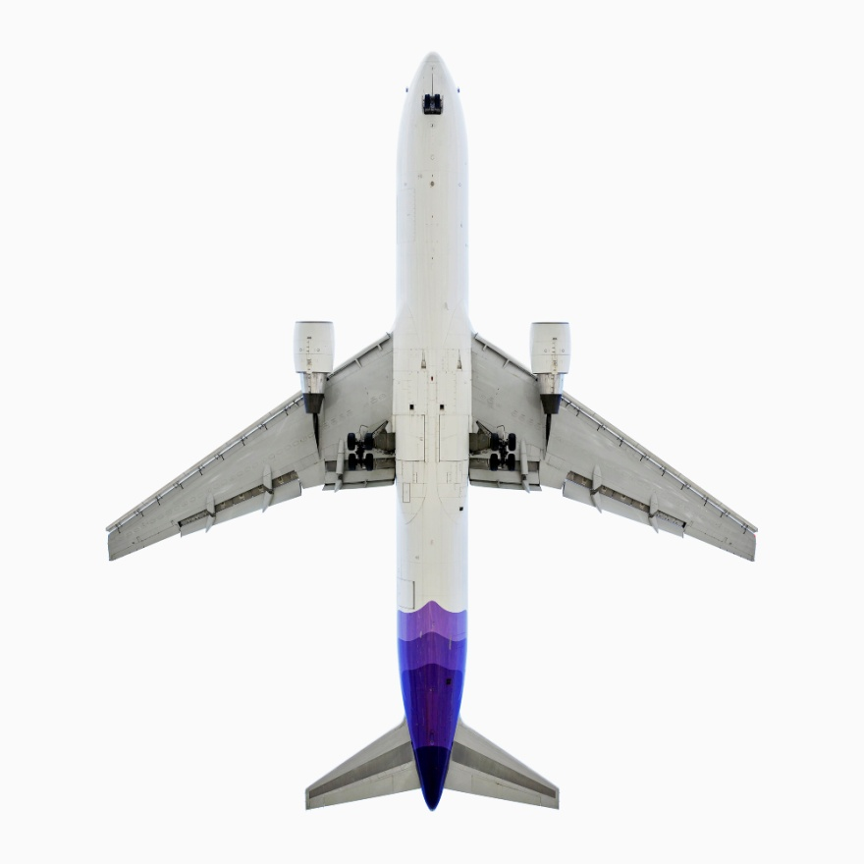

ABOUT JEFFREY MILSTEIN
Jeffrey Milstein is known for his mesmerizing aerial photographs of cities around the world. Born in the Bronx in 1944, he received a degree in architecture from the University of California, Berkley in 1968 and practiced as an architect before turning to photography in 2000. He earned his pilot’s license at the age of 17.

Milstein’s photography has been published in six books including his new book Paris From the Air (Welcome Books, Rizzoli, April 2021). His other books are Civilization: The Way We Live Now (Thames & Hudson, 2017); LA NY (Thames & Hudson, 2017); Small Dreams: 50 Palm Springs Trailer Homes, Schiffer Publishing, 2016), CUBA: Photographs by Jeffrey Milstein (Monacelli Press, 2010); and Aircraft: The Jet as Art, (Abrams, 2007). His work has appeared in the New York Times, Los Angeles Times, The Guardian, Esquire, Fortune, Time, Harper’s, Conde Nast Traveler, Vanity Fair, Die Zeit, Paris Match, and on the CBS Evening News with Scott Pelley.

Photographs by Milstein have been exhibited and collected throughout the United States and Europe. His award-winning aerial images as well as his typology of aircrafts have been shown at the Smithsonian National Air and Space Museum, Washington D.C.; Natural History Museum of Los Angeles; Ulrich Museum of Art, Wichita, KS; Brandts Museum, Odense, Denmark; among others, and are in the permanent collection of the Los Angeles Museum of Art; Smithsonian Museum, Washington, D.C.; George Eastman House, Rochester, NY; Portland Museum of Art, Portland, OR; and Akron Art Museum, Akron, OH. He lives in Woodstock, NY.

ABOUT ROBERT KLEIN GALLERY
Robert Klein Gallery ranks among the world's most prestigious showrooms of fine art photography. Celebrating its 40th anniversary this year, the gallery has developed an extensive and ever-changing inventory of 19th century, 20th century, and contemporary photographs. Participating in art fairs such as Art Basel, The Armory Show, Paris Photo, The Photography Show presented by AIPAD, Photo London, Intersect Aspen, and Photo LA, Robert Klein Gallery provides its contemporary artists with national and international exposure while exhibiting works by recognized masters such as Sebastião Salgado, Man Ray, Diane Arbus and Francesca Woodman. With decades of experience and a profound knowledge base, the gallery staff is committed to serving as a resource for both novice and seasoned collectors. Located at 38 Newbury Street in Boston, Robert Klein Gallery is currently open by appointment only. To contact the gallery please email info@robertkleingallery.com or call 617-267-7997.

###
PRESS CONTACT:
Nicole Straus Public Relations
Nicole Straus, 631-369-2188, 917-744-1040, nicole@nicolestrauspr.com
Margery Newman, 212-475-0252, MargeryNewman@gmail.com

Images from top: TK

